PRACTICLE TEST

ELECTIVE MODULE -1

QUESTION:3

HARDWARE/SOFTWARE:

1. WINDOWS 10/11
2. GOOGLE CROME/MOJILA
3. IBM CLOUD ACCOUNT
4. INTERNET

CLOUDANT:

1.Log in ibm cloud and search cloudant in catalog.

2.Type cloudant in the Search bar and click to open it.

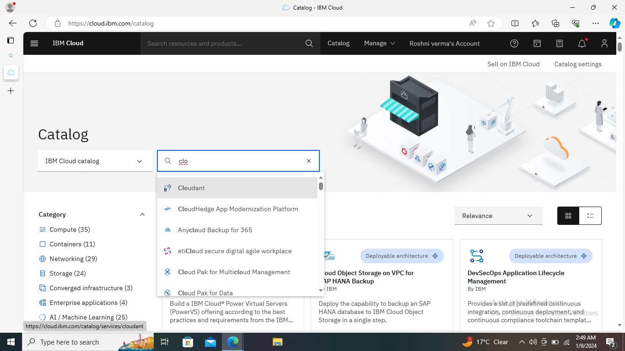

3.Select an offering and an environment.

4.Type an instance name.

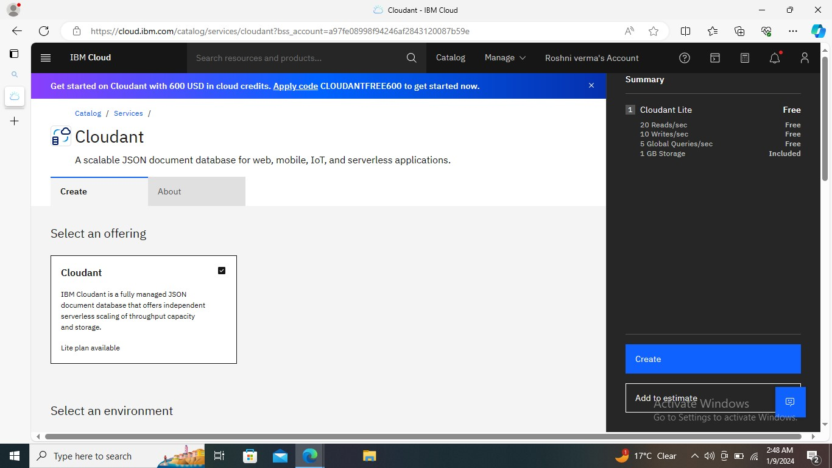

5.lounch the dashboard ,to get a new window

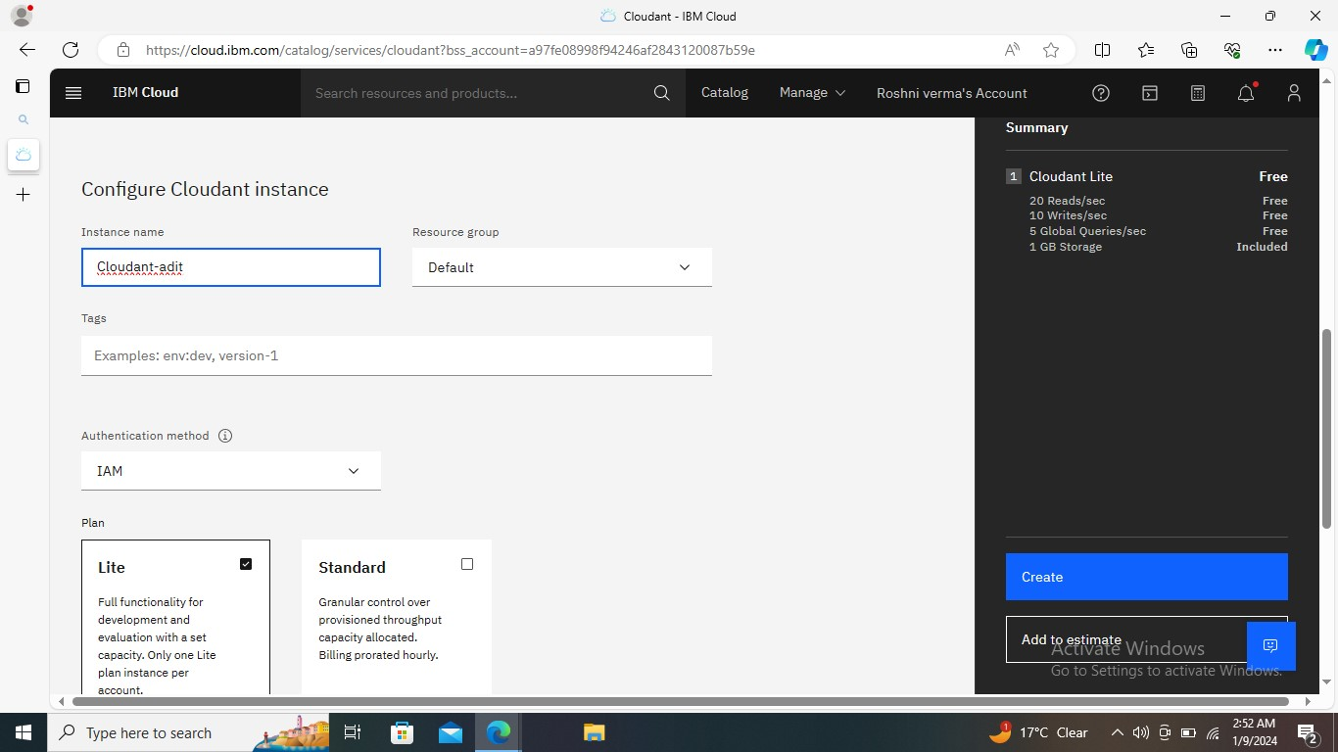

6.create a database

7. click on database name and select the database created

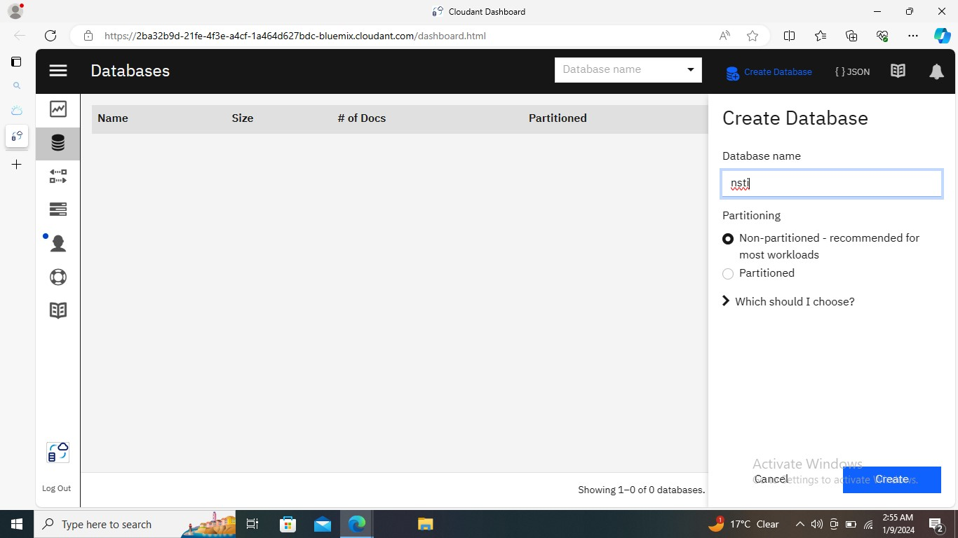

8. New document are created

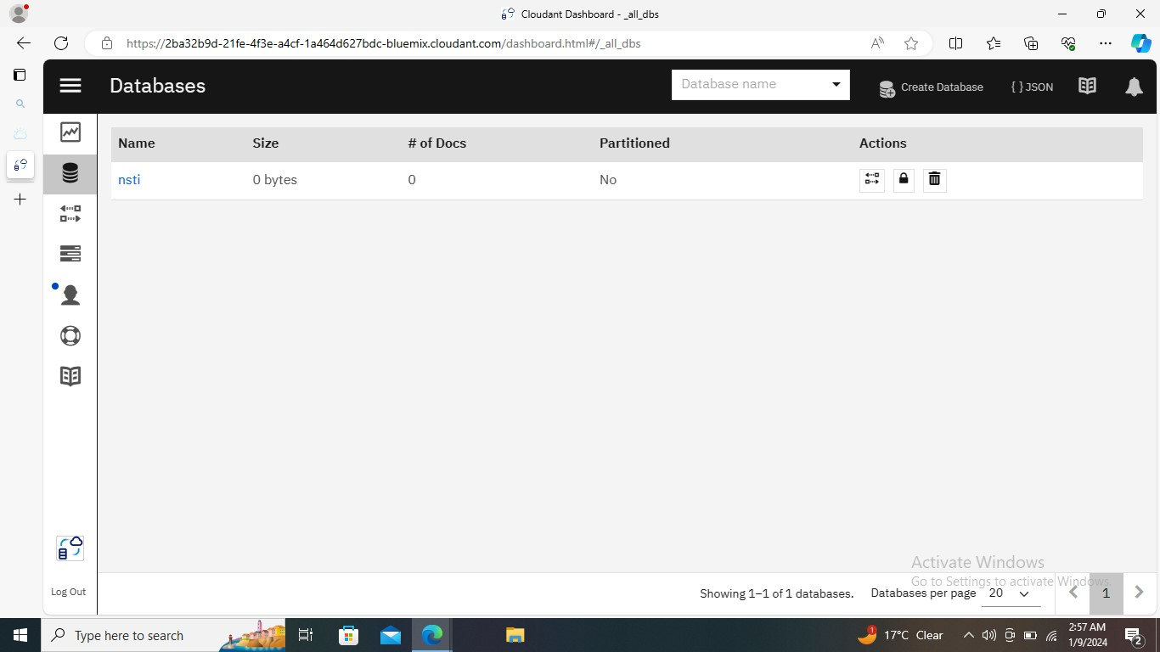

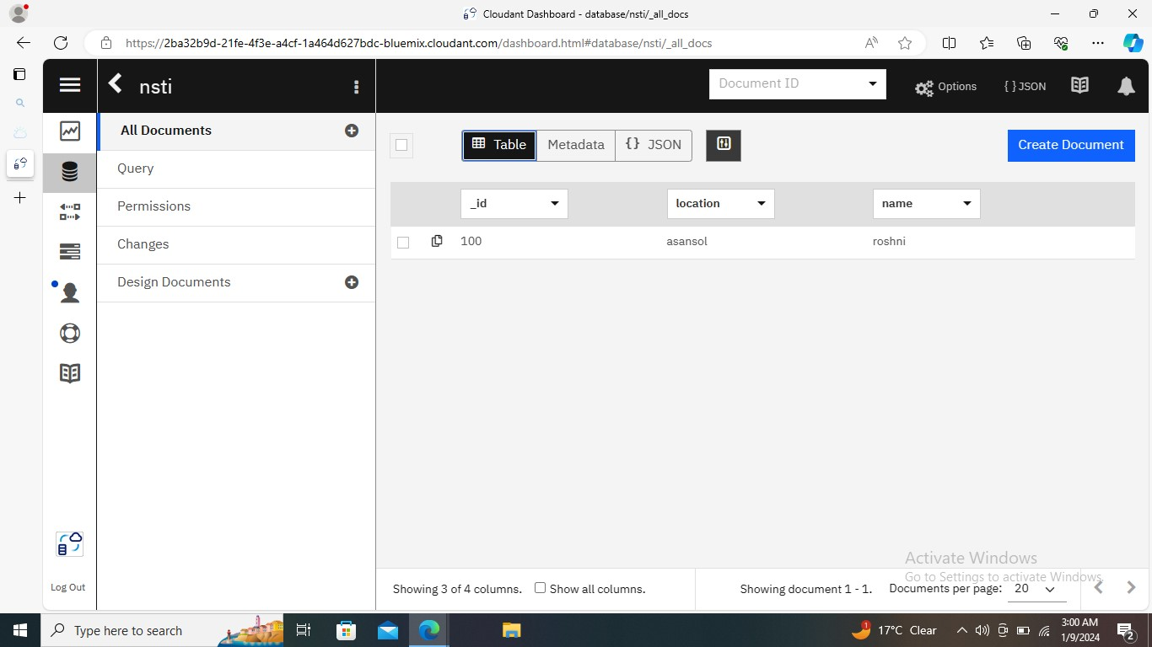

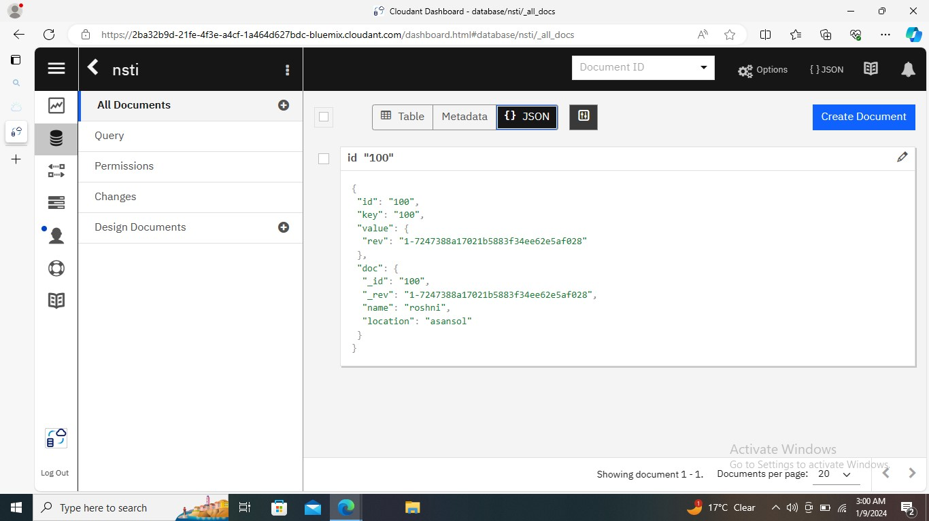

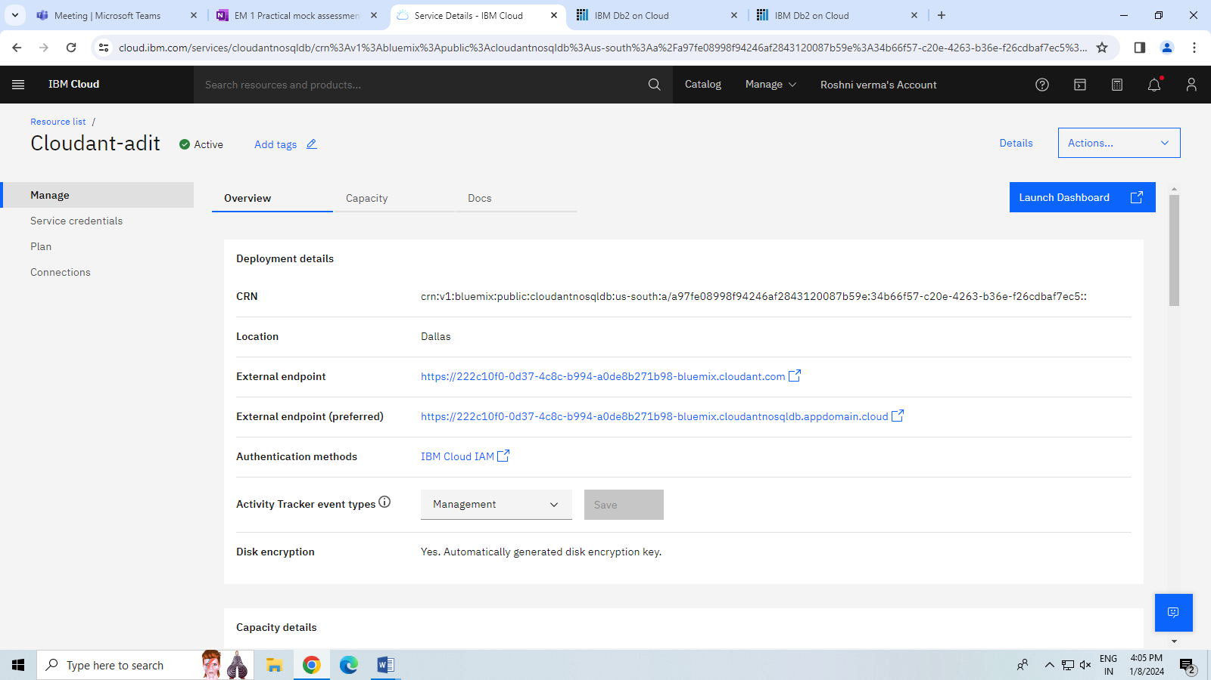

QUESTION-5 Invite users and add them in access groups using IAM in IBM Cloud

HARDWARE/SOFTWARE:

1. WINDOWS 10/11
2. GOOGLE CROME/MOJILA
3. IBM CLOUD ACCOUNT
4. INTERNET

STEP -1 Log in the ibm cloud and click on invite user.

STEP -2 Invite user lick then choose iam.

STEP -3 Another email are put and create.

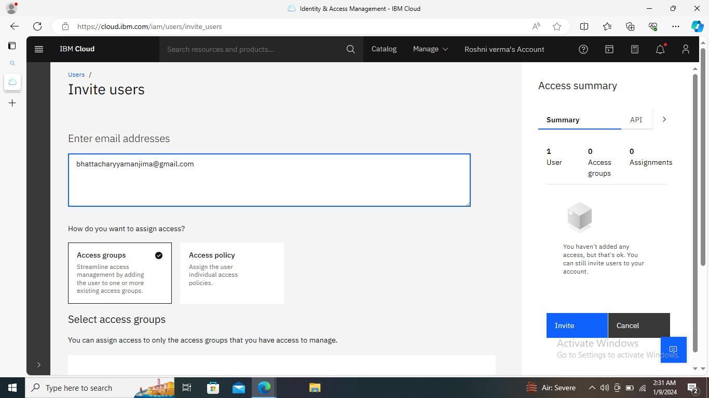

STEP -4 Send and show successfully sended.

STEP -5 Then cheak on email.

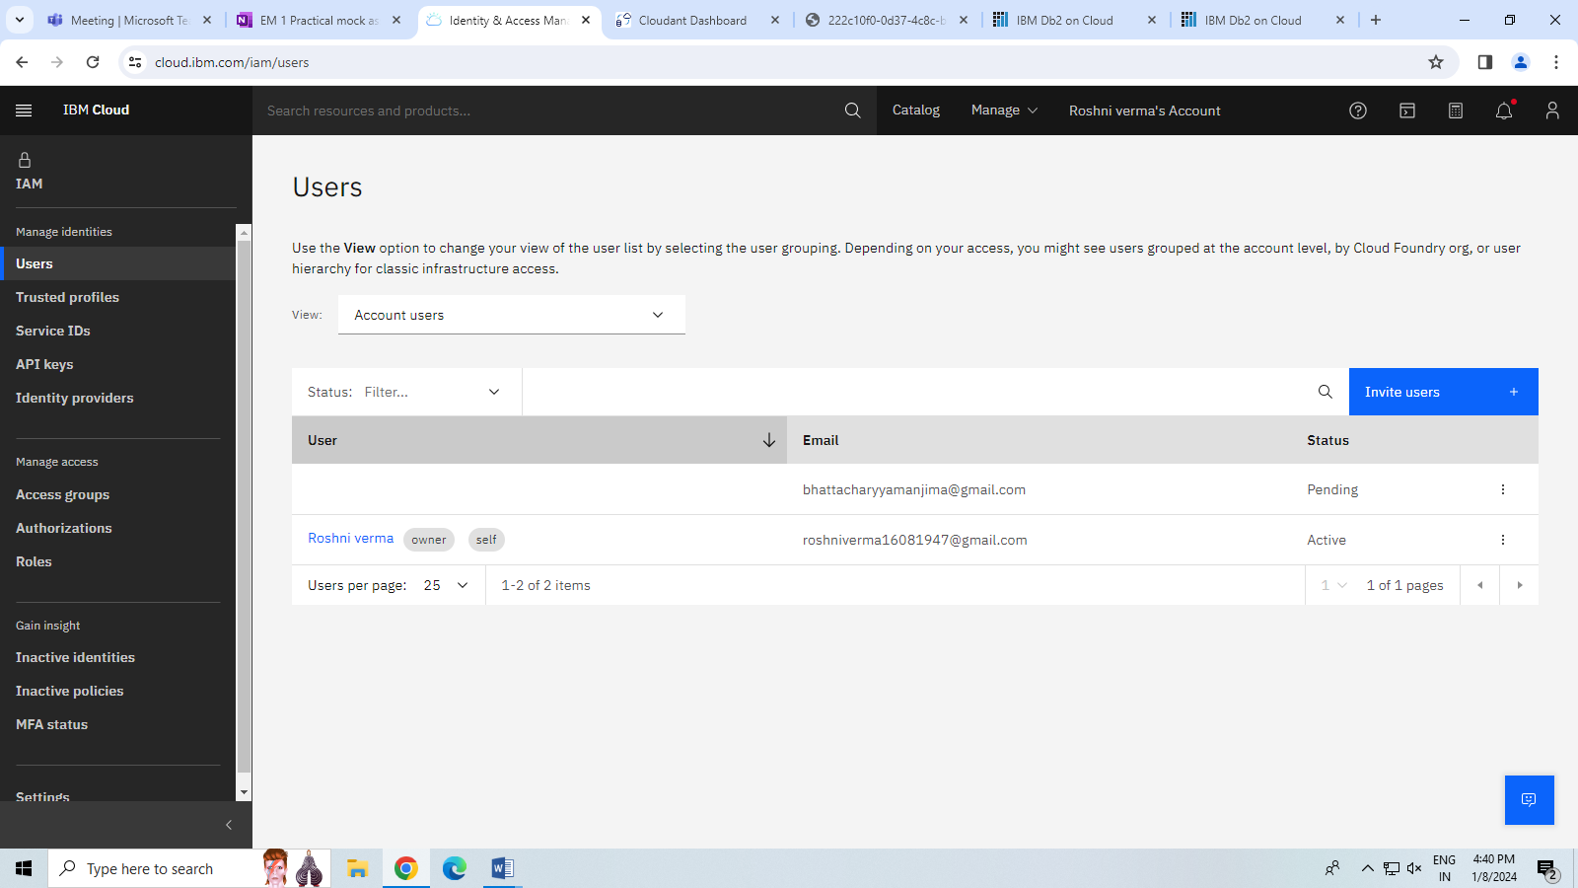

QUESTION -1 Creating a database & running SQL query on IBM db2. Load an external data(CSV) using db2.

HARDWARE/SOFTWARE:

1. WINDOWS 10/11
2. GOOGLE CROME/MOJILA
3. IBM CLOUD
4. INTERNET

STEP -1 LOG IN IBM CLOUD ACCOUNT

STEP -2 SEARCH DB2 IN CATALOG

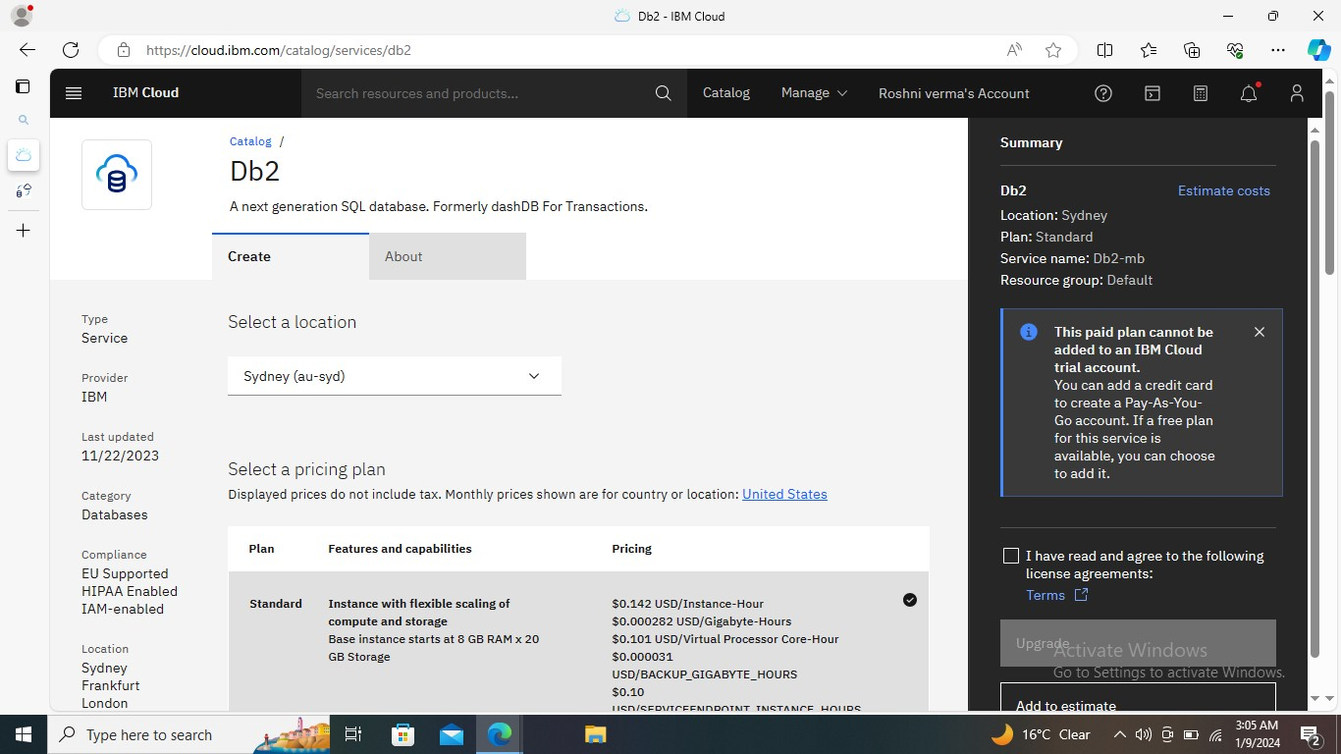

STEP -3 Choose a location and select a plan,put the service name then click on create button.

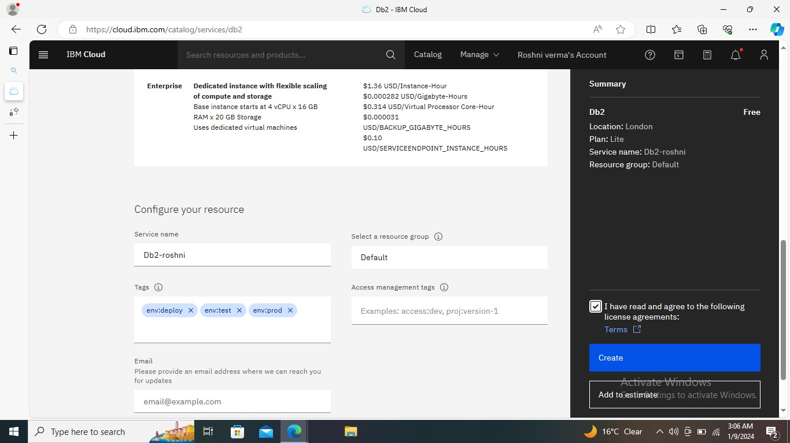

STEP -4 click on go to UI and create a table,insert data and run.

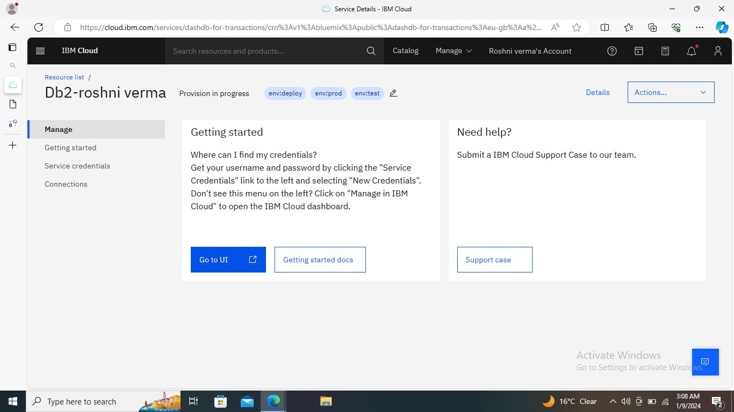

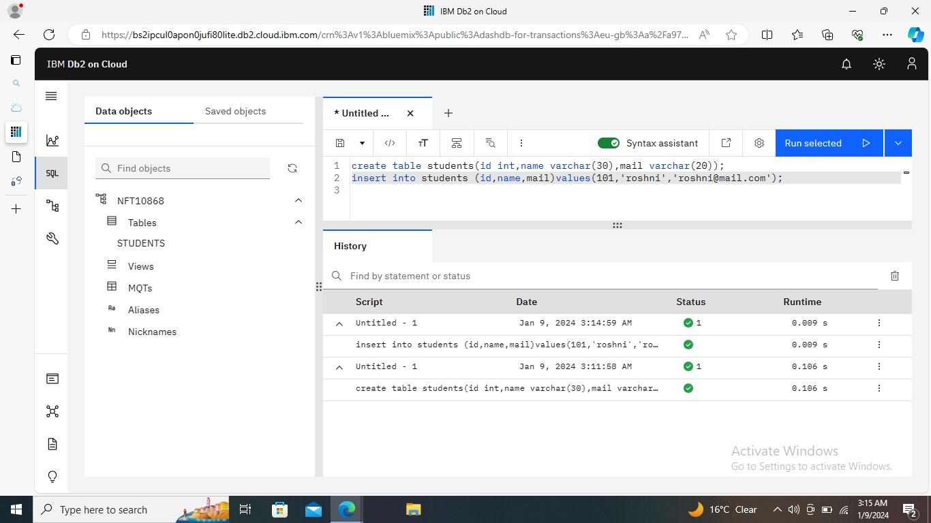

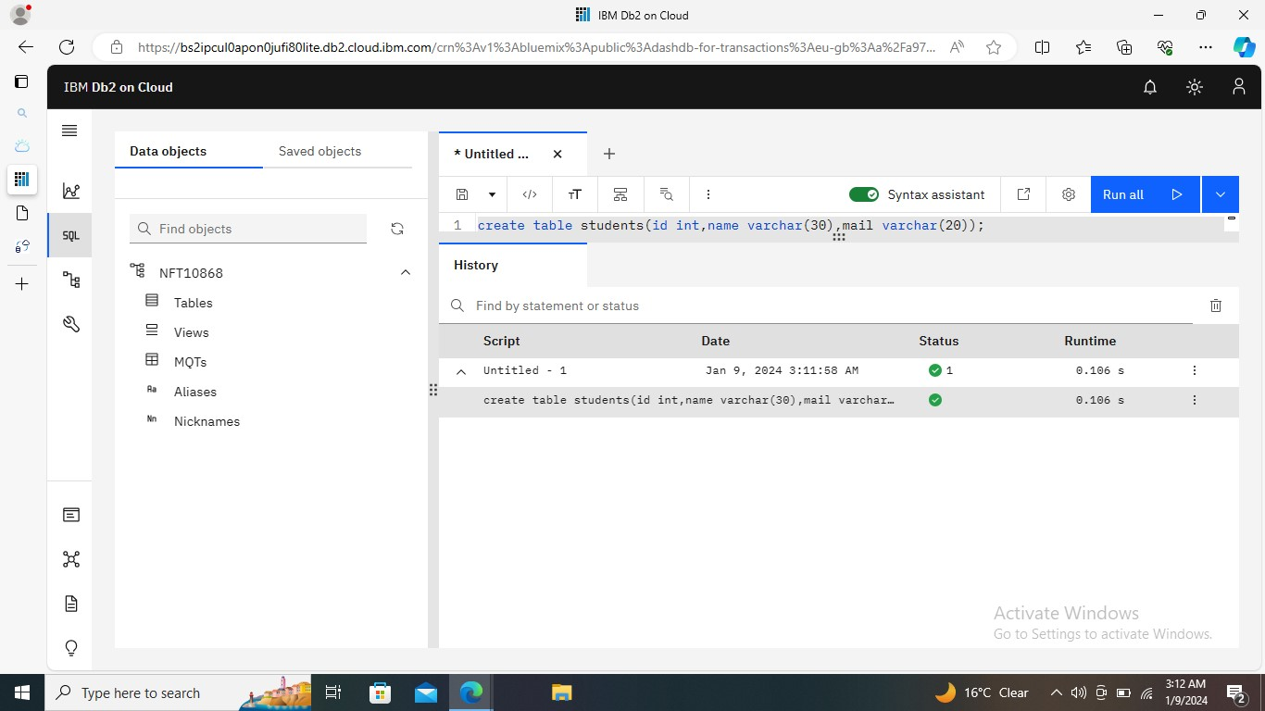

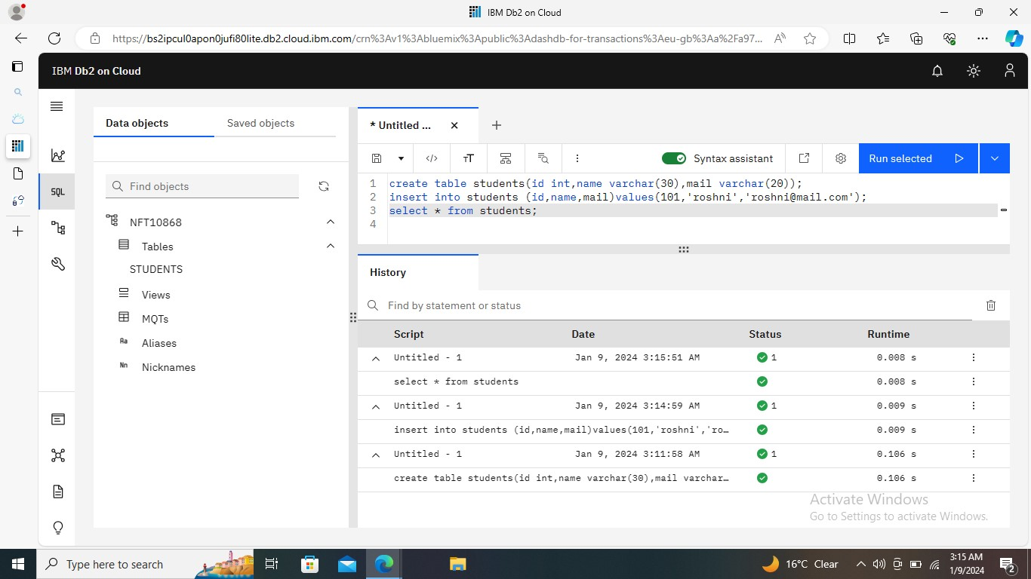

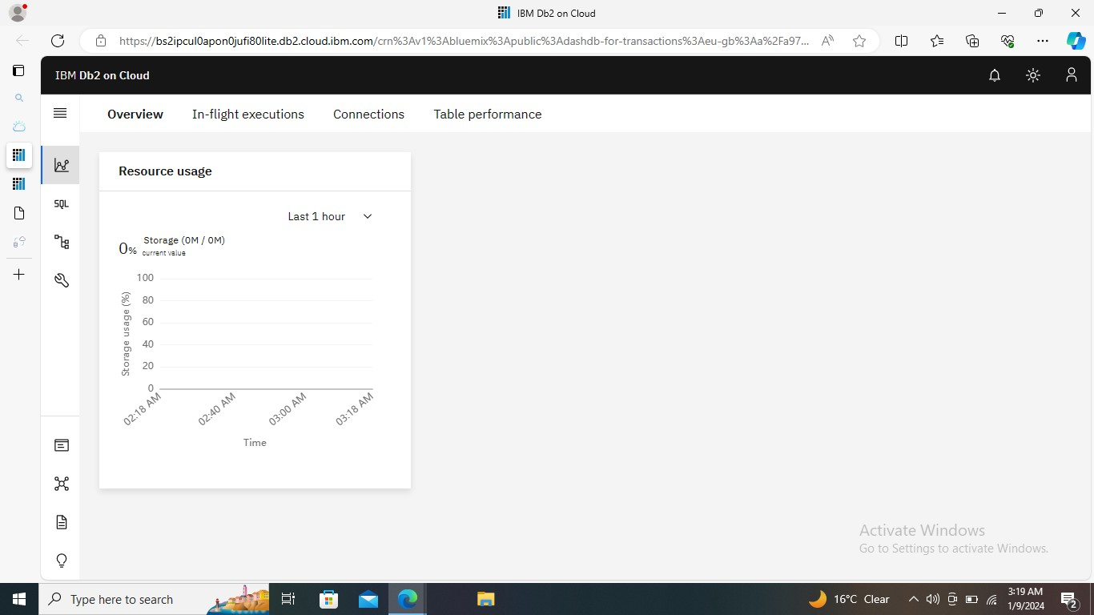

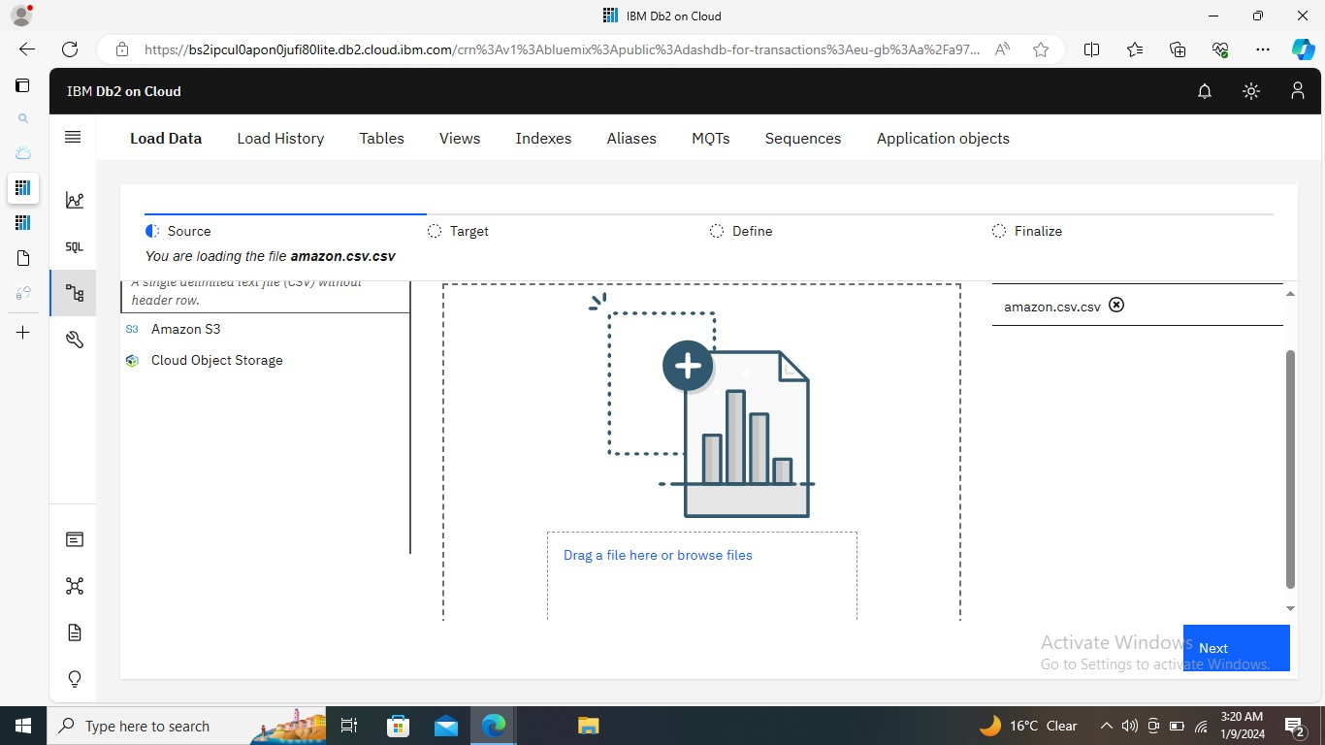

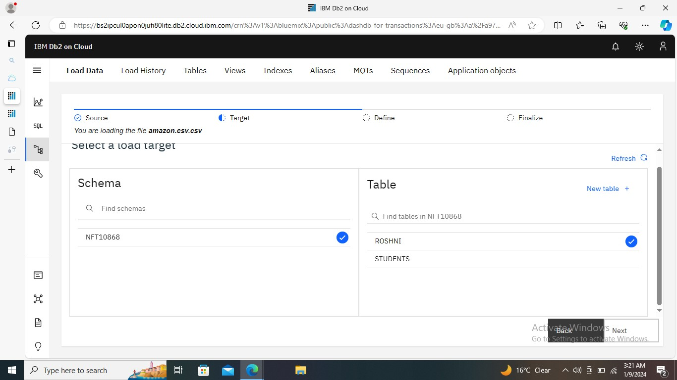

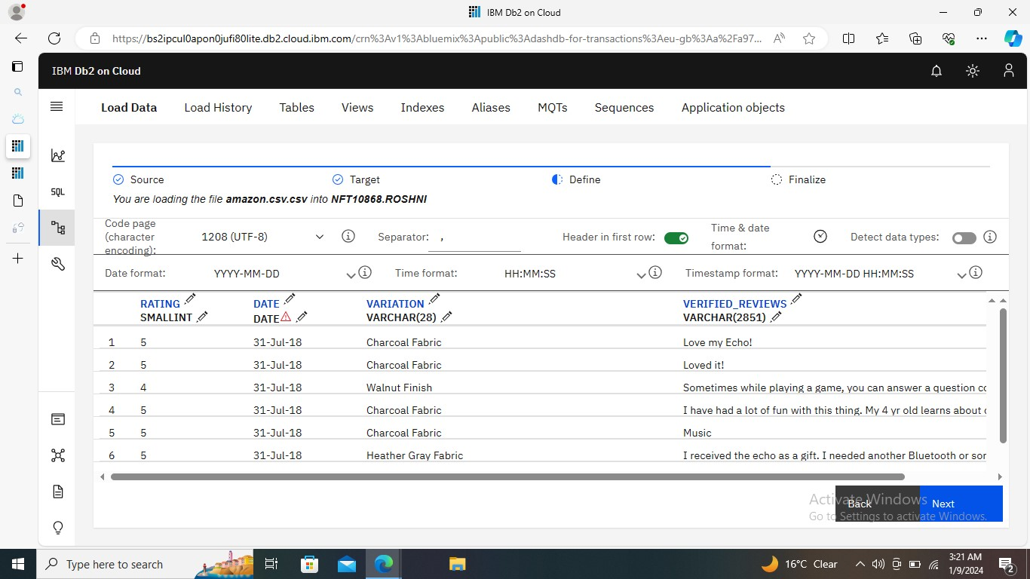

Step-5 click on ui and sql upload a csv file.

QUESTION -4 Customize your IBM Cloud Dashboard.

HARDWARE/SOFTWARE:

1. WINDOWS 10/11
2. GOOGLE CROME/MOJILA
3. IBM CLOUD
4. INTERNET

STEP -1 LOG IN IBM CLOUD ACCOUND.

STEP -2 create a dashboard click and management select the box.

STEP -3 put the dashboard name and save it.

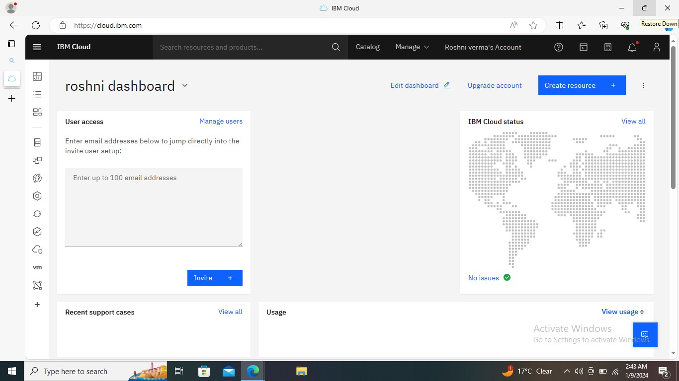

STEP -4 all reasource on my account choose .then share the dashboard.

STEP -5

Question- 2

Step -1 LOG IN IBM CLOUD ACCOUND.

Step -2 search data engine in catalog and select.and create.

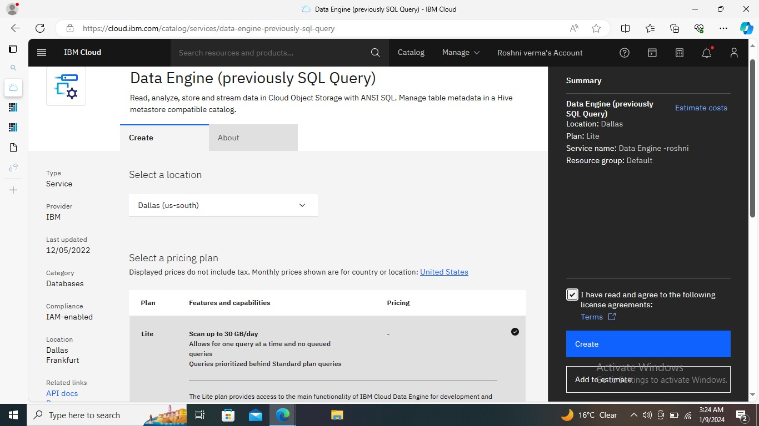

Step-3 click on launch data engine ui.

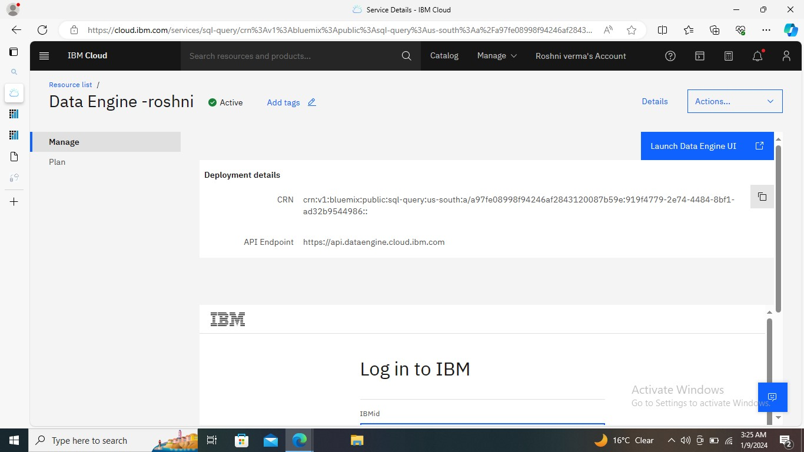

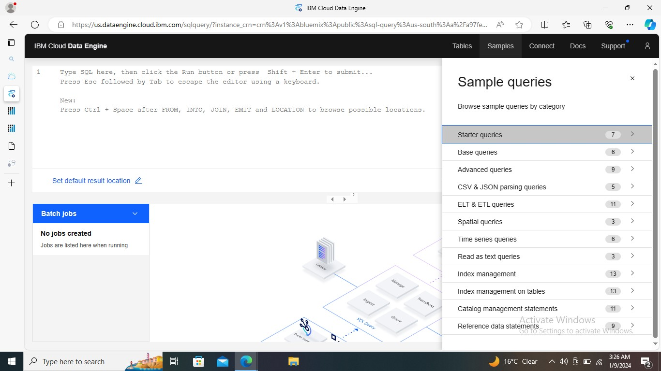

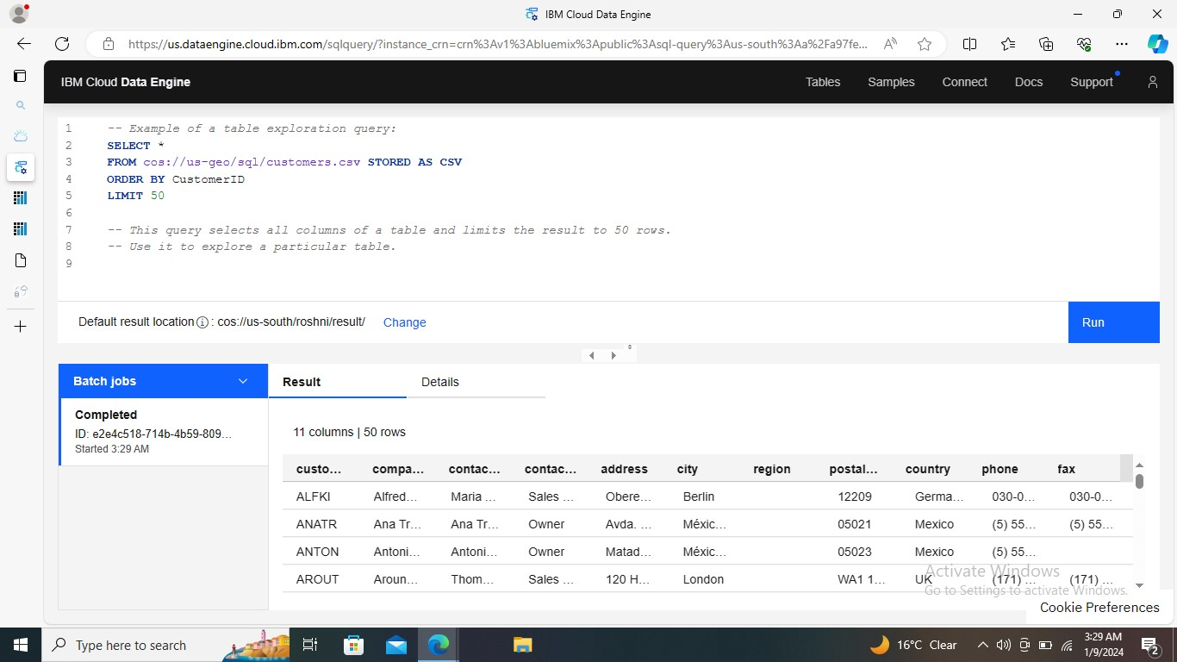

Step-4 choose a sample button and click on starter queries .

Step -5 table select and put the storage and bucket name.

Step-6 run

Step-7